MONTHLY TEST - JULY 2019
Marks obtained:

Total:
30
Name: ____________________________
Grade: I Section___
Subject: EVS
Date: 02.08.19
Time: 1 Hour

I. Mark the joints in our body. 5 X 1 = 5
Knee, elbow, ankle, wrist, shoulder

II. Identify the pictures. 4x1=4
1. ________________ 2. ______________________
3. ________________ 4. 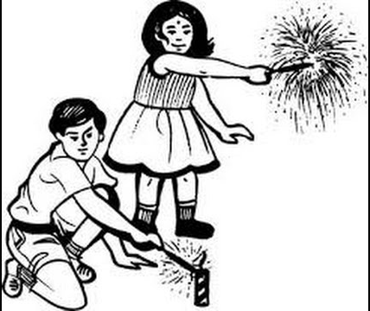________________

III. Answer the following. 3x2=6
1. How many sense organs are there in our body?
____________________________________________________________________________________________________________________________
2. What are the two types of families?
____________________________________________________________________________________________________________________________
3. Which is your favourite festival?
____________________________________________________________________________________________________________________________

IV. Fill in the blanks by observing the neighbourhood map. 5x1=5
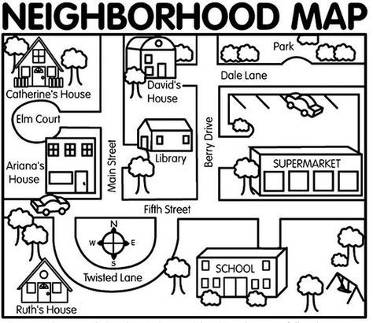
1. The building opposite to David’s house is the______________________.
2. Ruth’s house is in _____________________ Lane.
3. ___________________ is in the Dale Lane.
4. There are ________________ houses in the map.
5. Is there a school in the picture? _______________ ( yes / no)
V. Draw the picture of your family and colour it. 5

VI. Match the sense organs with their functions. (5x1=5)

